**Create a GKE Cluster using Terraform**

**Set up a 2-node GKE (Google Kubernetes Engine) cluster using Terraform.**

A: We have installed Terraform & Google SDK on local machine using commands on CMD

B: We have created new project name ID “shining-expanse-420607” on GCP console

C: We have to save file as “main.tf” in terraform folder as given below commands for execute process.

After applying all the commands then cluster was created in GCP Console with 2 nodes .

Below is screenshot for your reference

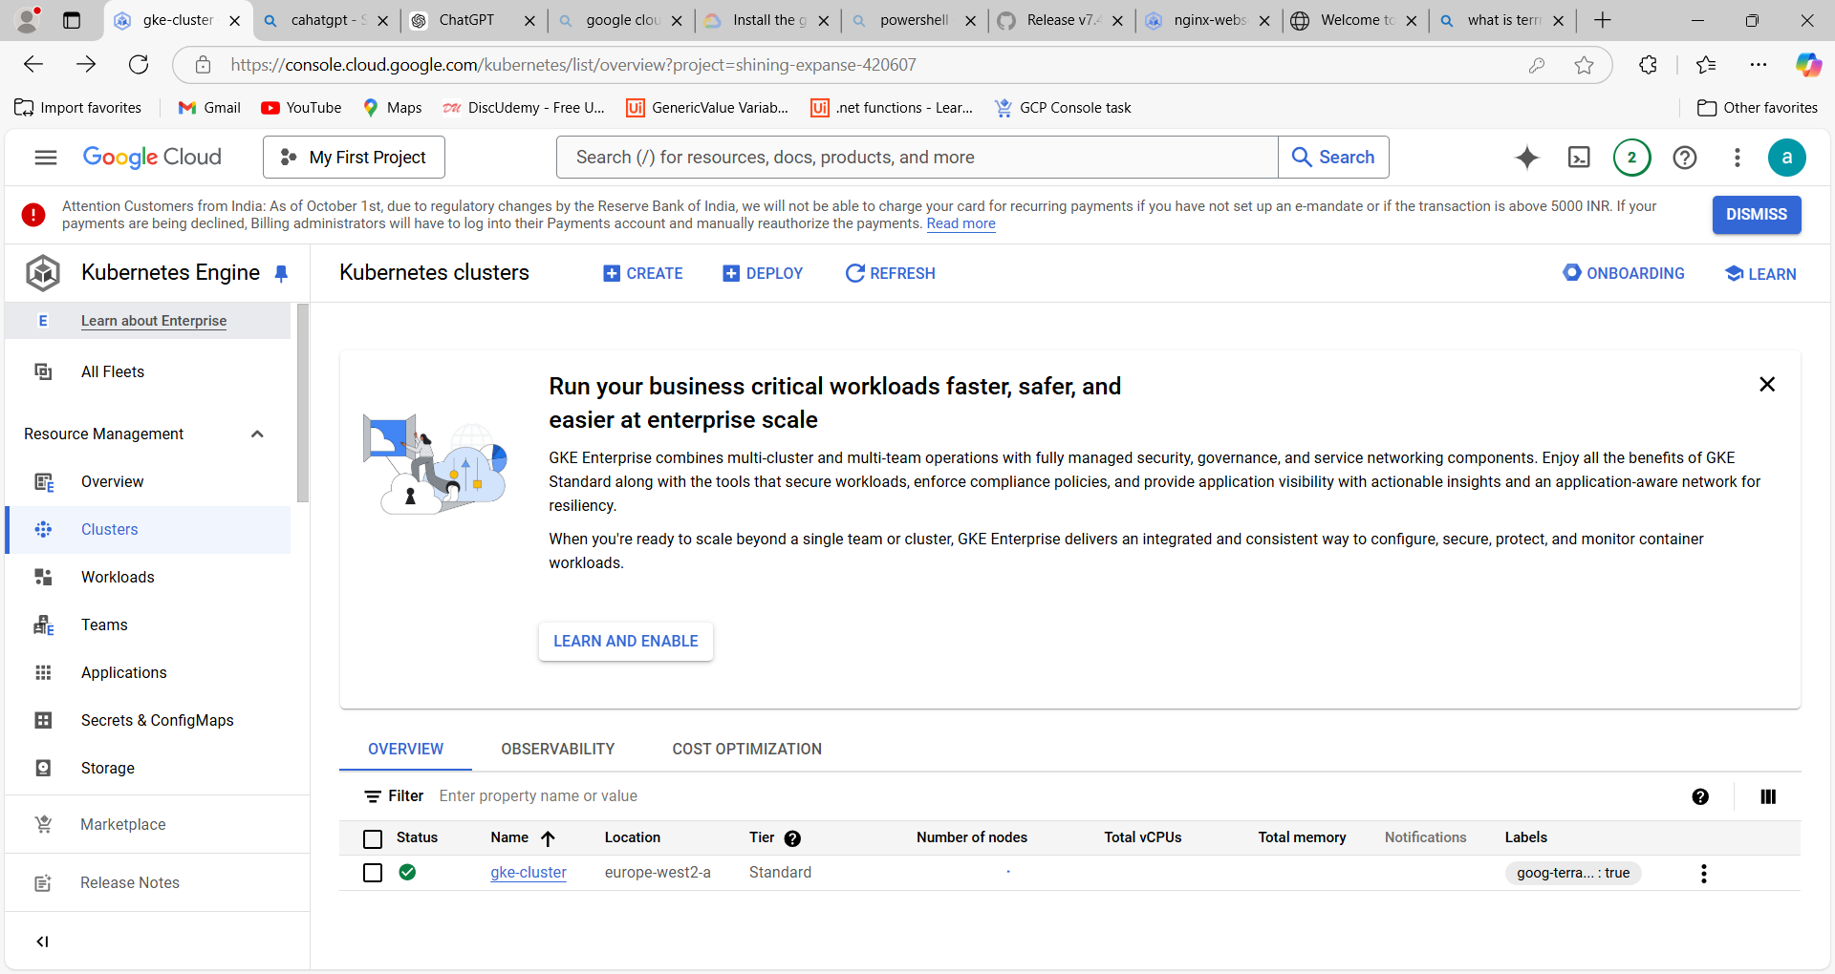

**Deploy a test application on the cluster.**

A: We have deployed a test application names as (nginx webserver) on GCP console with 3 Pods .

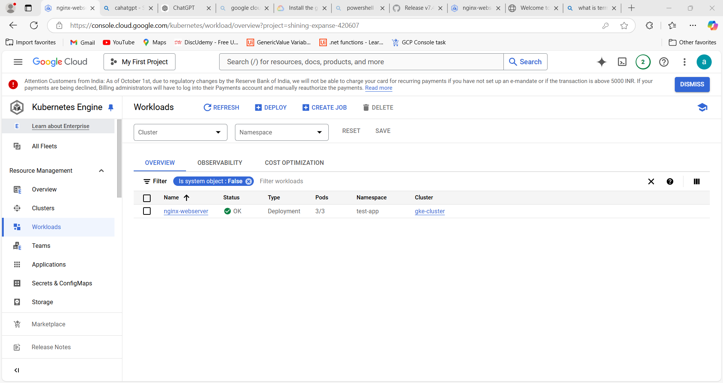

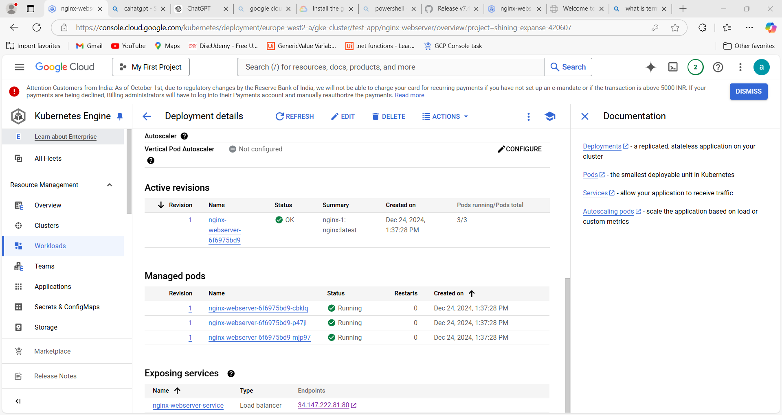

**Configure the cluster to demonstrate auto-scaling in response to increased traffic.**

A: When CPU was increased to more then 80% then replica will change to more then 4 or 5 count.Below is the example screenshot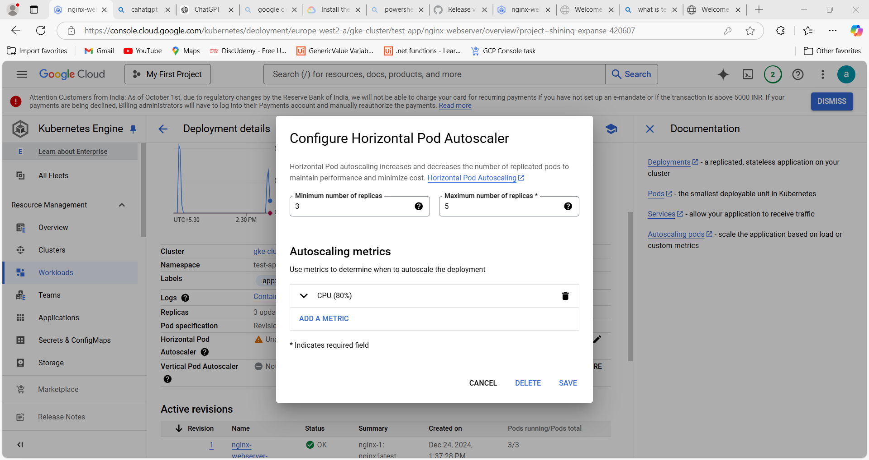

B: Once Auto Scaling Traffic has been increased means pods will be increased automatically it depends upon.

**Deploy an Application on GKE using Cloud Build**

1. I am using Cloud Build, and I have written a cloudbuild.yaml file in the repository. Whenever we commit changes to the main branch, Cloud Build automatically builds the Docker image, stores it in Google Container Registry (GCR), and deploys the application to the Kubernetes cluster.